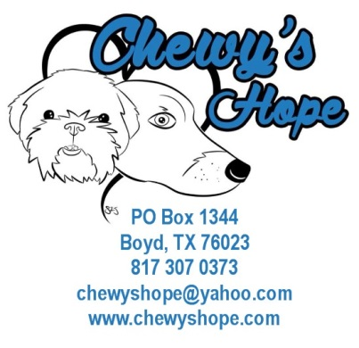

ADOPTION APPLICATION

Thank you for contacting CHEWY’S HOPE about adopting a new member of your family. We would love to match you with a great rescue dog. Our goal is to get dogs out of kill shelters, off chains, out of pens, and into responsible, loving, permanent homes. Please fill out this form so that we may find out more about you and your family, so that both you and your dog may find the right fit.
Please Note: We are committed to matching the right dog to the right family so all will have many happy years together. Our adoption process includes the completion of an application, possible home visit, veterinary reference, adoption fee and contract.

Our adoption fees are:
- Our adoption fees are: (all dogs are fully vetted)
- $175 for dogs under 6 years
- $150 for dogs 6 years and over

Adopter has 48 hours to take the dog to a vet and dog can be returned to the rescue and fees returned with veterinarian verification the dog is unhealthy.

Today's Date ___________________________

List any Specific Dogs you are interested in:
- ______________________________________________________________

- ______________________________________________________________

Applicant’s Name ________________________________________________________________

Address Street _________________________________________________________

City ___________________________________________________State ________ZIP______________

Cell # ____________________________________Home Phone # ________________________________

Email ________________________________________________________________________________

Your Age: _________________
Spouse/Roomate Name _______________________________Spouse/Roomate Age ________________

How did you hear about CHEWY’S HOPE?

Why do you want a dog?

What research have you done on dogs and dog breeds?

What are you looking for in a dog: sex, age, breed, color?

Do you have any children? If so, how many children, what are their ages, and boys or girls?

Do you currently have pets? If so, list breed, age, sex and temperament(alpha or submissive).

Have you ever adopted a dog from a Rescue? ☐ Yes ☐ No

If yes, please list name(s) of Rescues

Please also list Microchip number(s)

Are these pets on heartworm prevention? ☐ Yes ☐ No

If so, what brand - Heargard/Interceptor,etc.? ____________________________________

Who is your current Veterinarian? ______________________________________________

Veterinarian's Address?
Veterinarian’s Phone #_______________________

What pets have you owned in the past 5 years and where are they now?

Is your yard fenced? ☐ Yes ☐ No How high is your fence? ______________________

If your fence is multiple heights, please describe below.

What type of fence do you have? ______________________________________________________________

What size is your yard? __________________________________________________________

Describe where you live:

Will your gates be locked to protect your dog? ☐ Yes ☐ No

Do you rent? ☐ Yes ☐ No If so, please provide the name and phone number of landlord.
If you do rent and the name and phone number or landlord are not submitted on the application, this will delay the processing time. Please fill out all information and check with your landlord before starting the process.

Would you ever give your dog up? ☐ Yes ☐ No If so, why?

If you ever had to surrender your dog for any reason, do you promise to return it back to CHEWY’S HOPE and not take it upon yourself to re-home the dog? ☐ Yes ☐ No
How many adults are in your household on a daily basis? _______________________________________

What hours would the dog be alone? _______________

Where would the dog stay when no one is home? ___________________________

Where would the dog stay when someone is home? __________________________

Where would the dog stay when the family is out of town? _________________________________

Do you crate your pets? ☐ Yes ☐ No
How will you and your family spend time with the dog?

Would you be willing to take your dog to obedience classes? If no, why?

SIGNATURE________________________________________ Date________________________________
Thank you for filling out our application. You will be contacted after your application is processed and send you a ADOPTION CONTRACT.
This application may be scanned and saved. It can either be electronically submitted to chewyshope@yahoo.com.
or mailed to:
Chewy’s Hope
PO Box 1134
Boyd, TX 76023

